**PRAKTIKUM SISTEM OPERASI**

**MODUL 11**



**Nama : NICKY JULYATRIKA SARI**

**NIM : L200200101**

**PROGRAM STUDI**

**INFORMATIKA**

**FAKULTAS KOMUNIKASI DAN INFORMATIKA**

**UNIVERSITAS MUHAMMADIYAH SURAKARTA**

**TAHUN 2021/2022**

* Kegiatan 1. First-Come, First-Served (FCFS)
  1. Bukalah program OSSim, selanjutnya pilih menu processes -> process scheduling.
  2. Selanjutnya pilihlah setting dan pilih algoritma First-Come, First-Served (FCFS).
  3. Tabel

|  |  |  |  |  |
| --- | --- | --- | --- | --- |
| Proses | Arrival time | Burst time | Service time | priority |
| P0 | 0 | 7 | 0 | 4 |
| P1 | 1 | 3 | 7 | 2 |
| P2 | 2 | 10 | 10 | 1 |
| P3 | 3 | 2 | 20 | 3 |

* 1. Screenshot

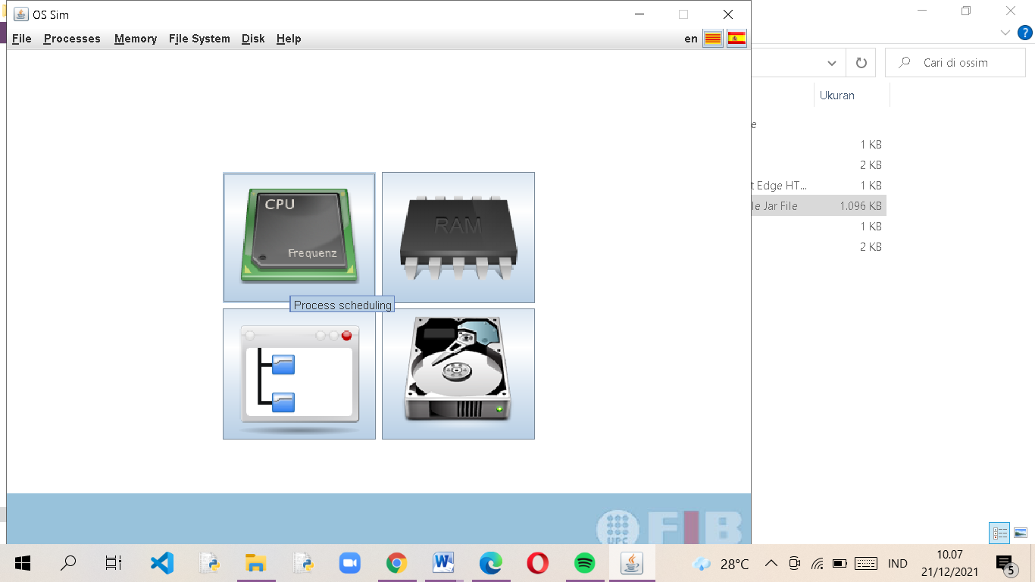

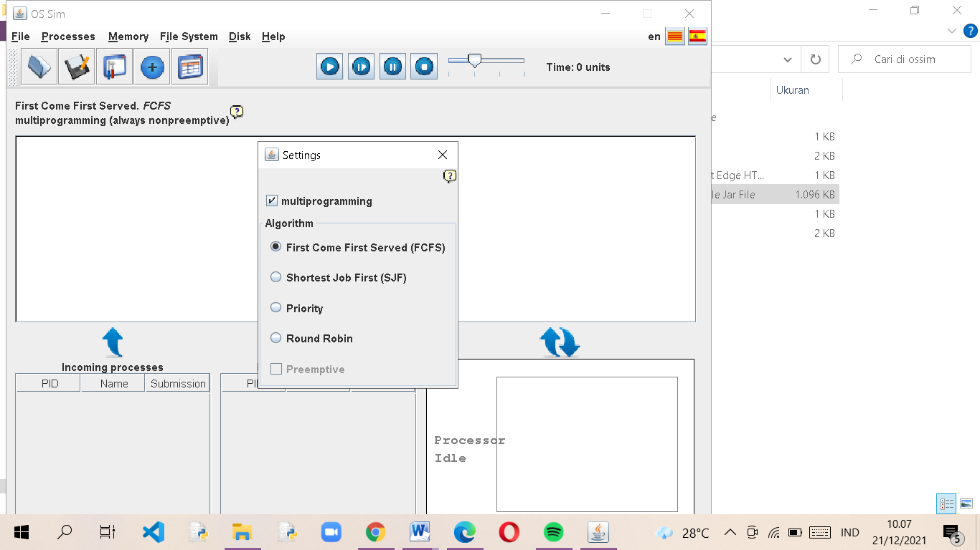

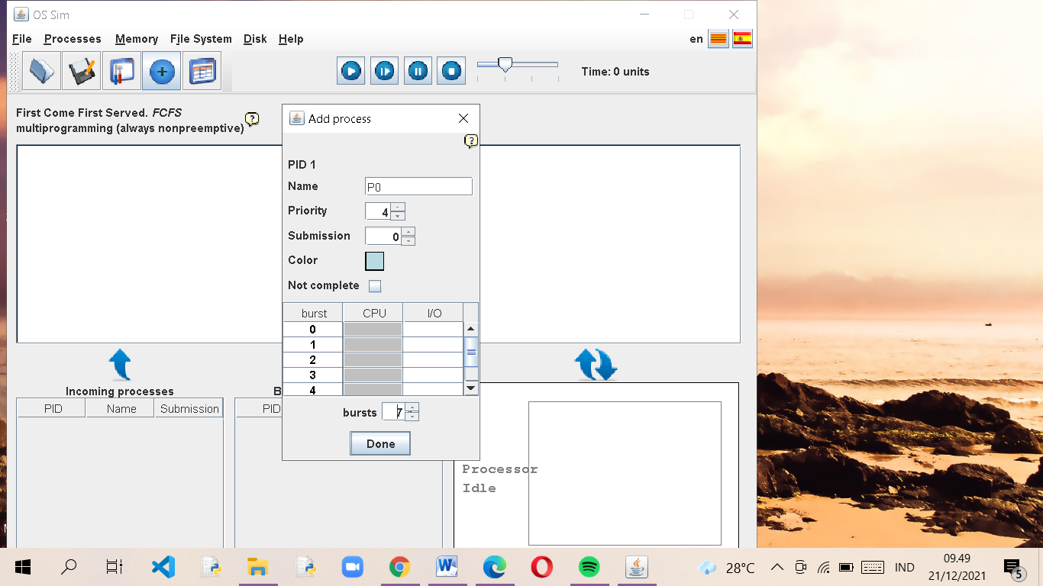

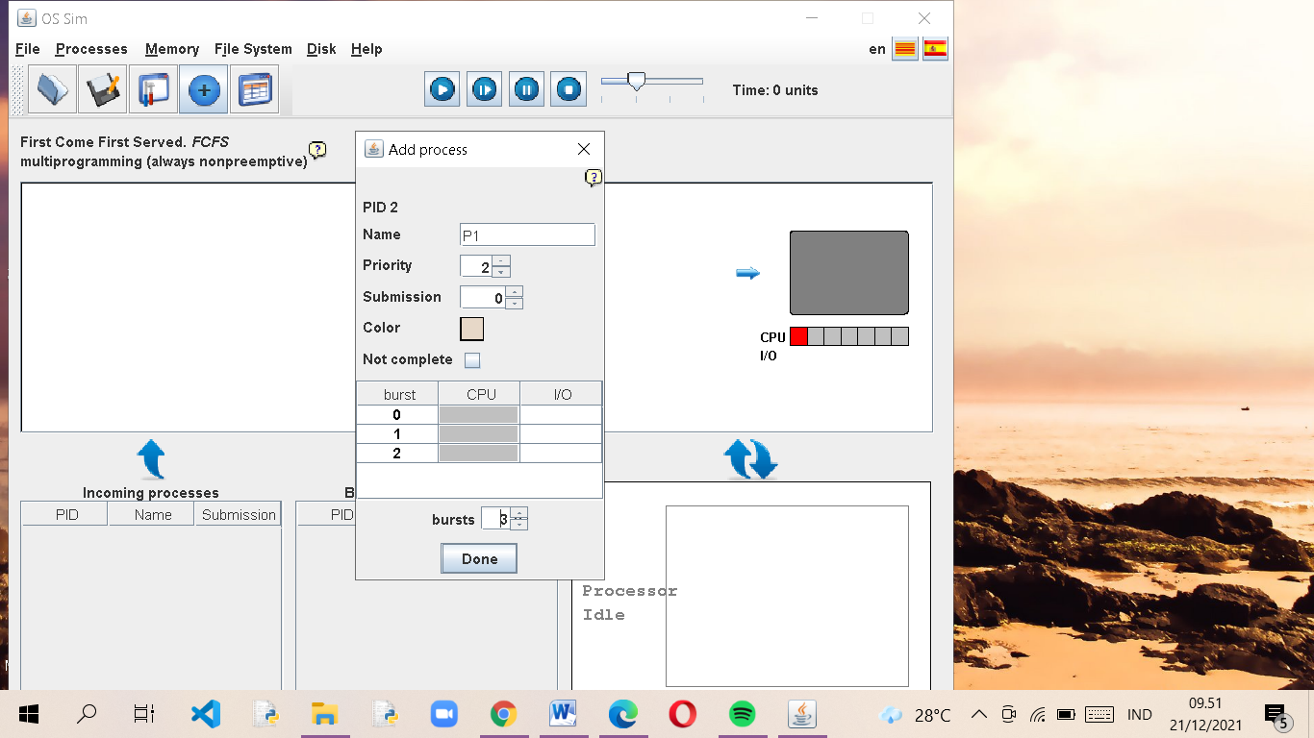

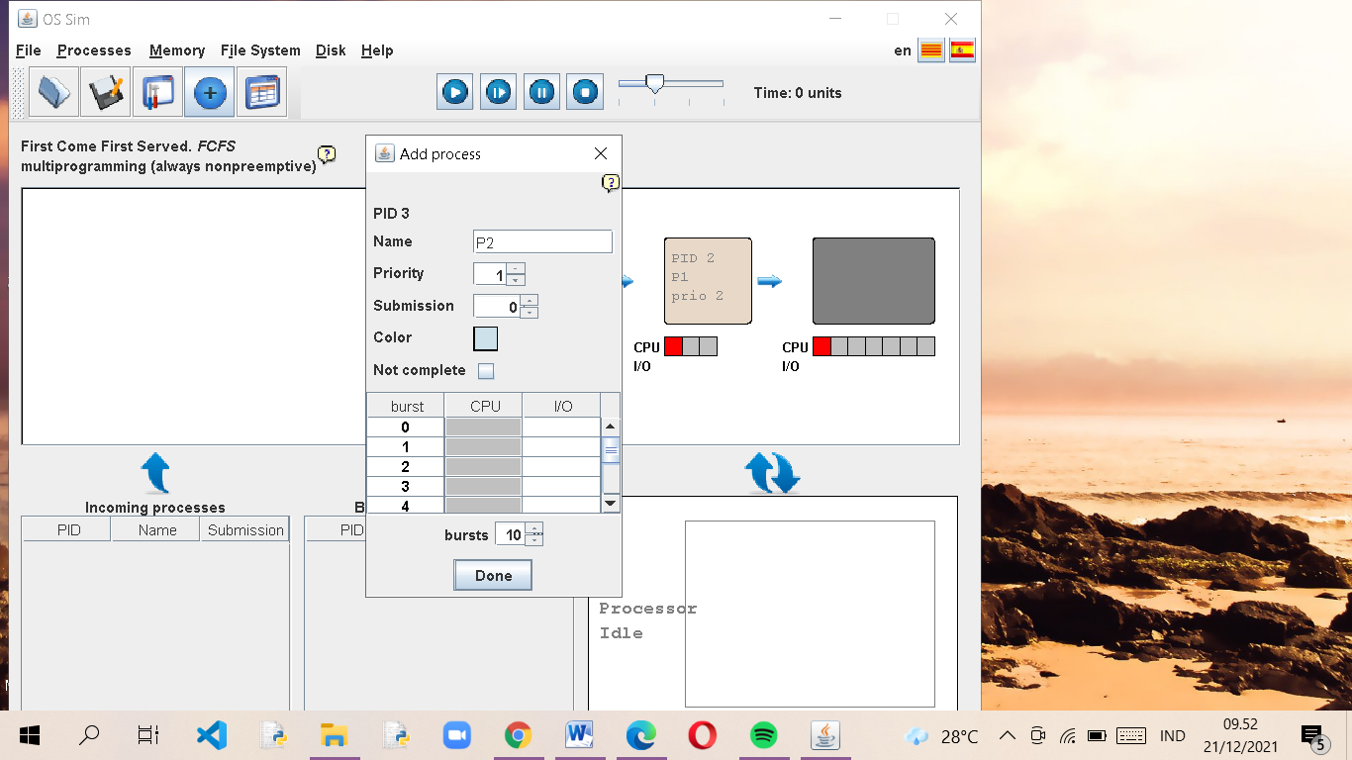

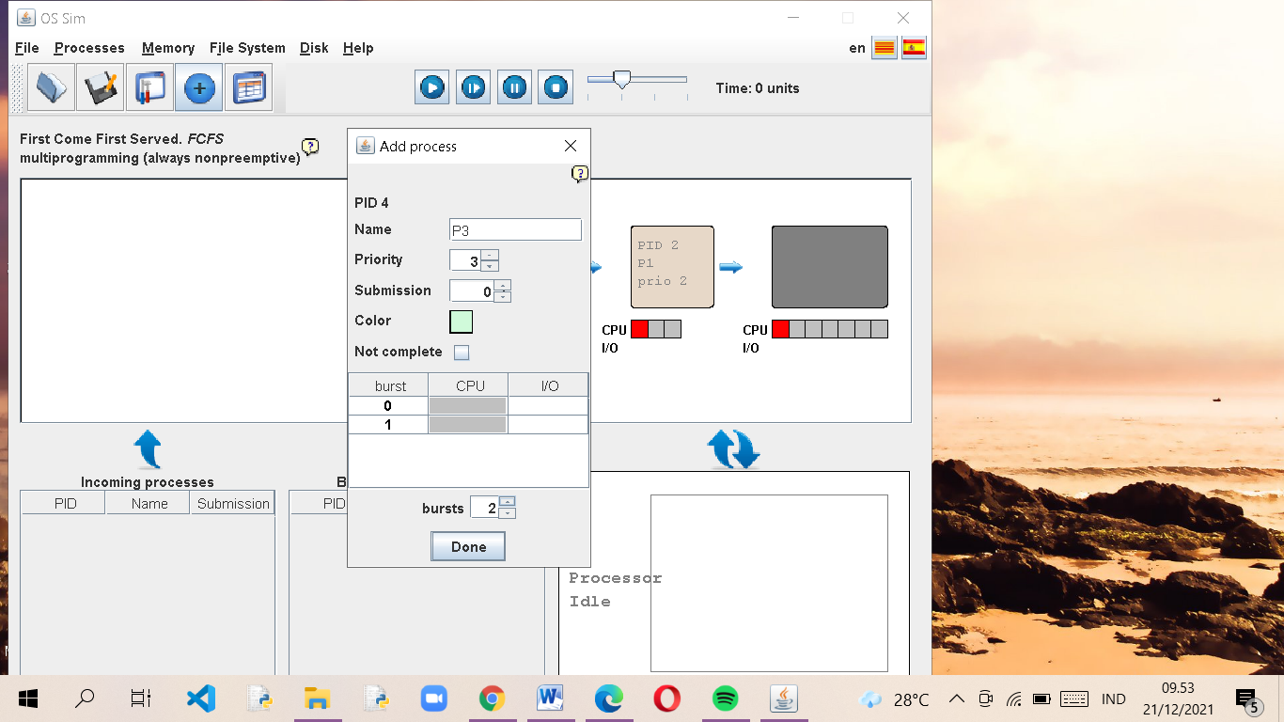

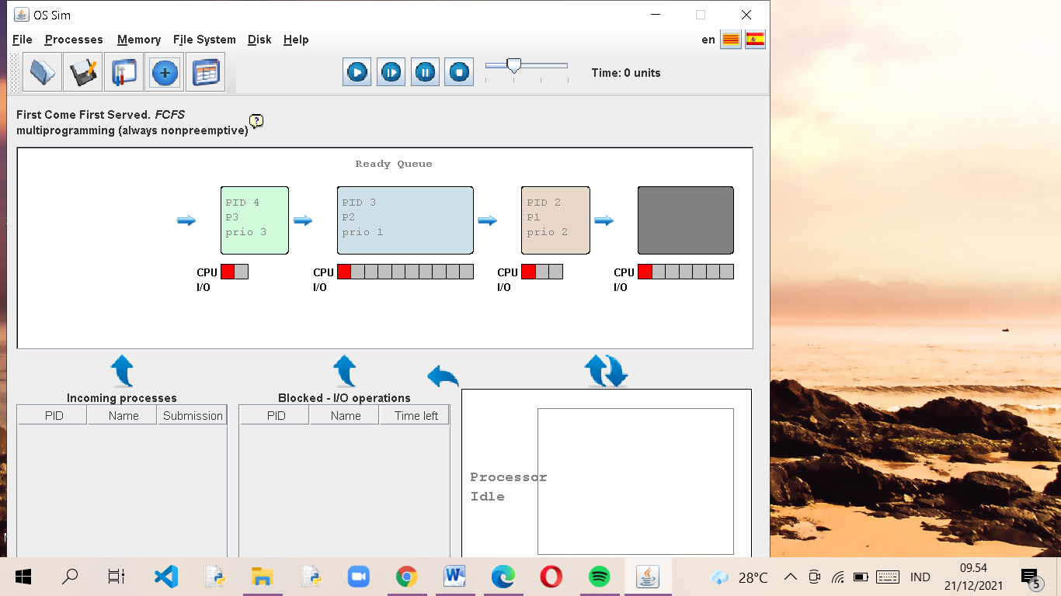

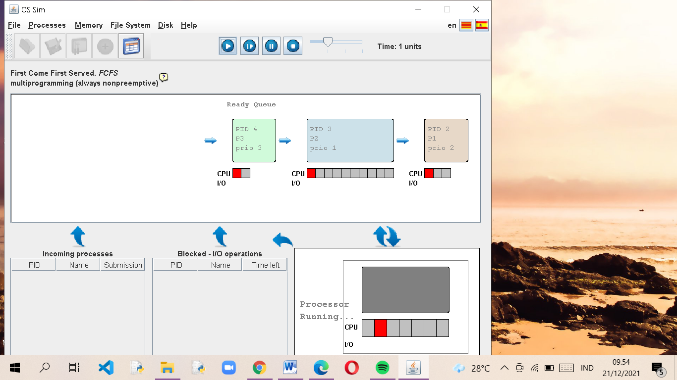

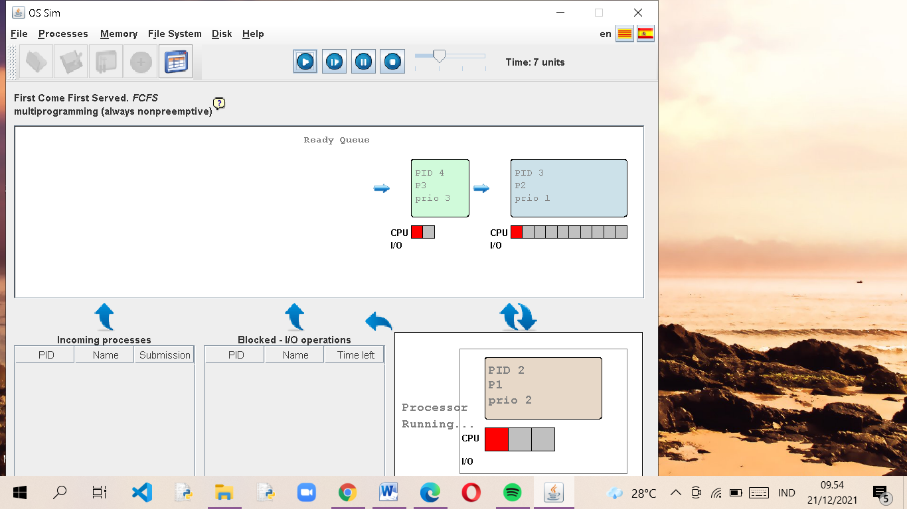

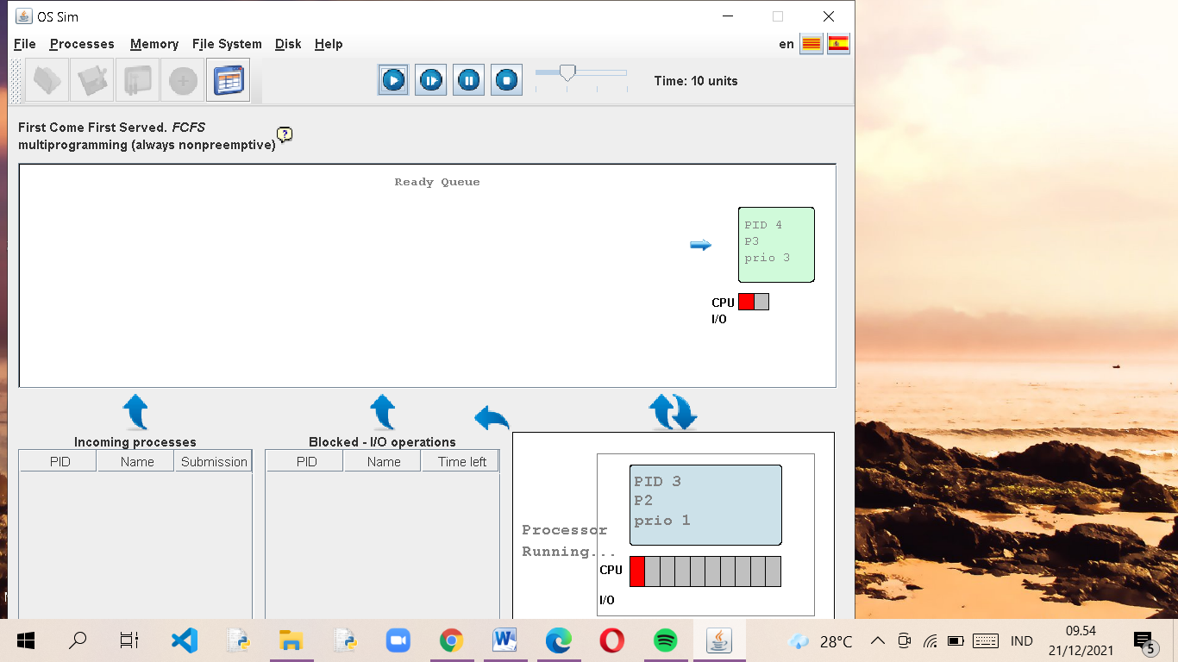

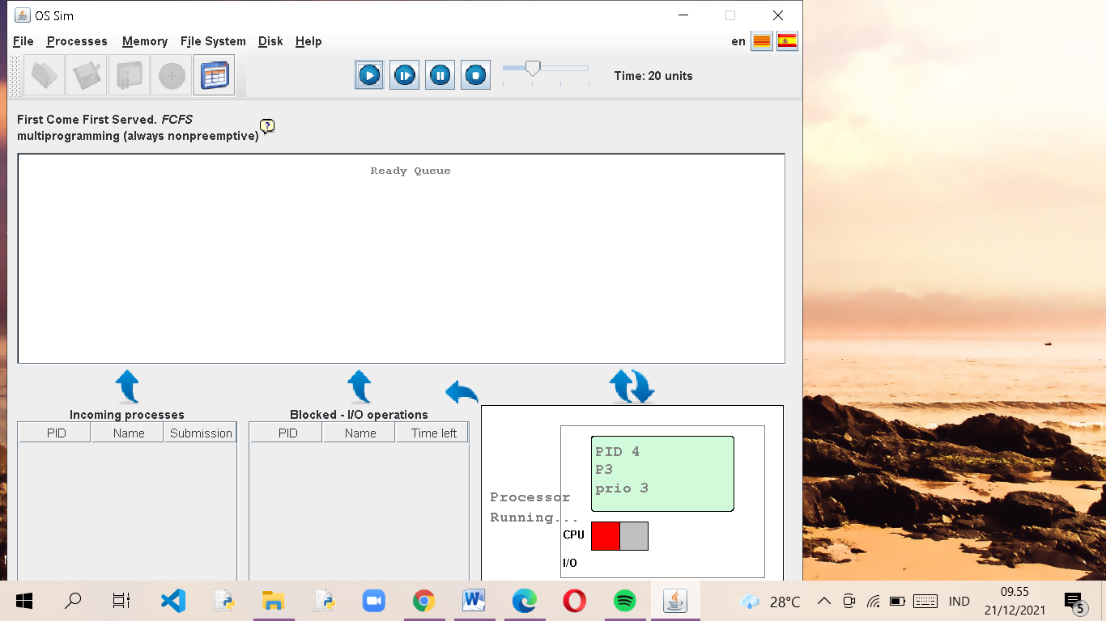

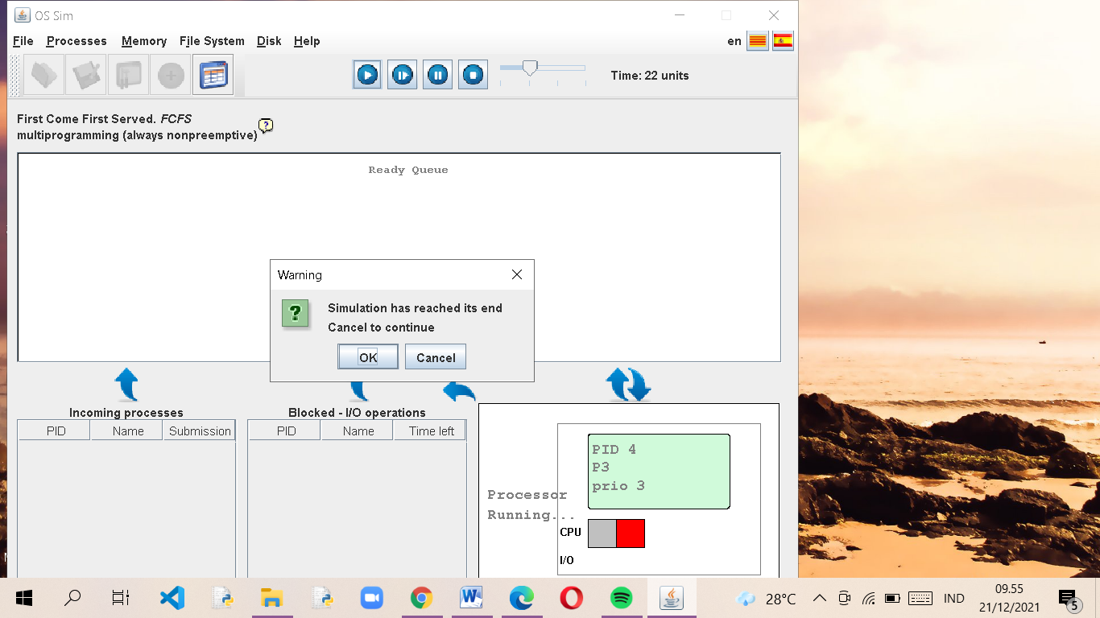

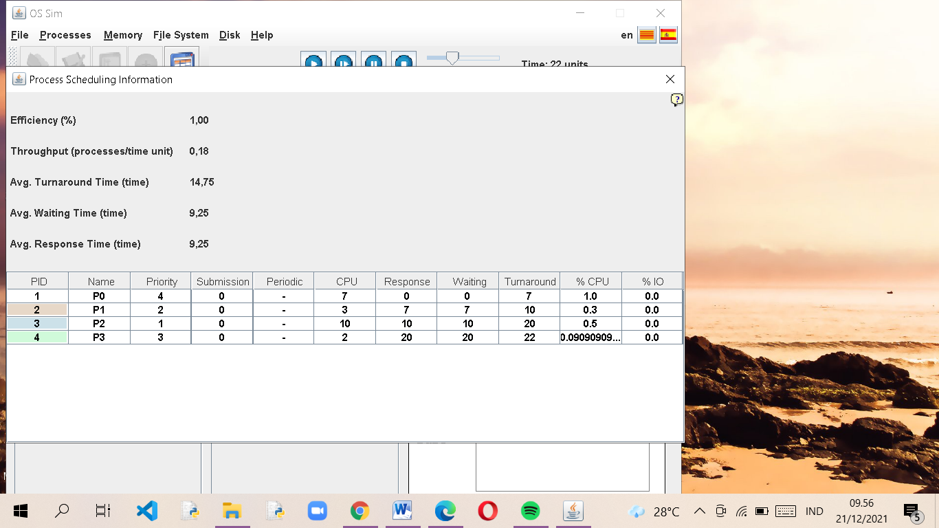

* 1. Tabel

|  |  |
| --- | --- |
| Process | Wait time |
| P0 | 0 |
| P1 | 7 |
| P2 | 10 |
| P3 | 20 |
| Avg. Waiting time | 9.25 |
| Avg. Turnaround time | 14.76 |
| Avg. Response | 9.25 |